Project Development Phase
Model Performance Test

Date | 03 October 2026
Team ID | SWTID-2026-8647
Project Name | Implement Client Script & UI Policy (Incident)
Maximum Marks

Model Performance Testing:
Project team shall fill the following information in model performance testing template.
S.No. | Parameter | Values | Screenshot
1. | Configuration Summary | ServiceNow Incident configuration using UI Policy, UI Policy Actions and Client Scripts.  Focus: mandatory, visible and read-only field behavior plus client-side validation.  Execution result: To be verified during implementation. | 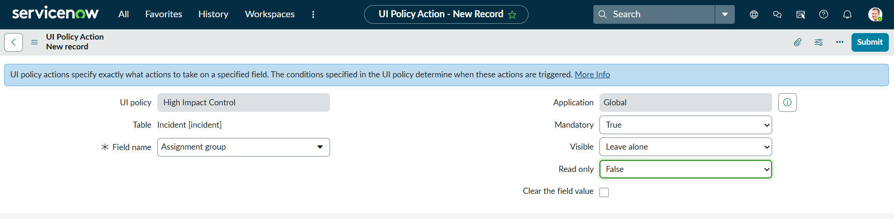  UI Policy Action evidence  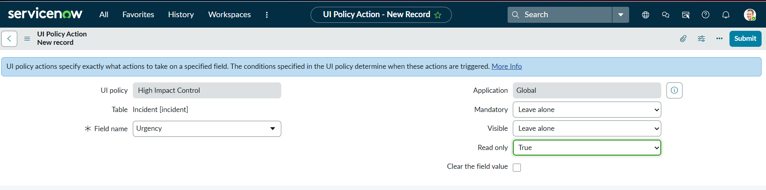  UI Policy Action evidence
2. | Functional Validation | Mandatory field behavior: Assignment Group.  Read-only behavior: Urgency.  Client-side behavior: Impact-based urgency handling.  Validation result: To be verified during implementation. | 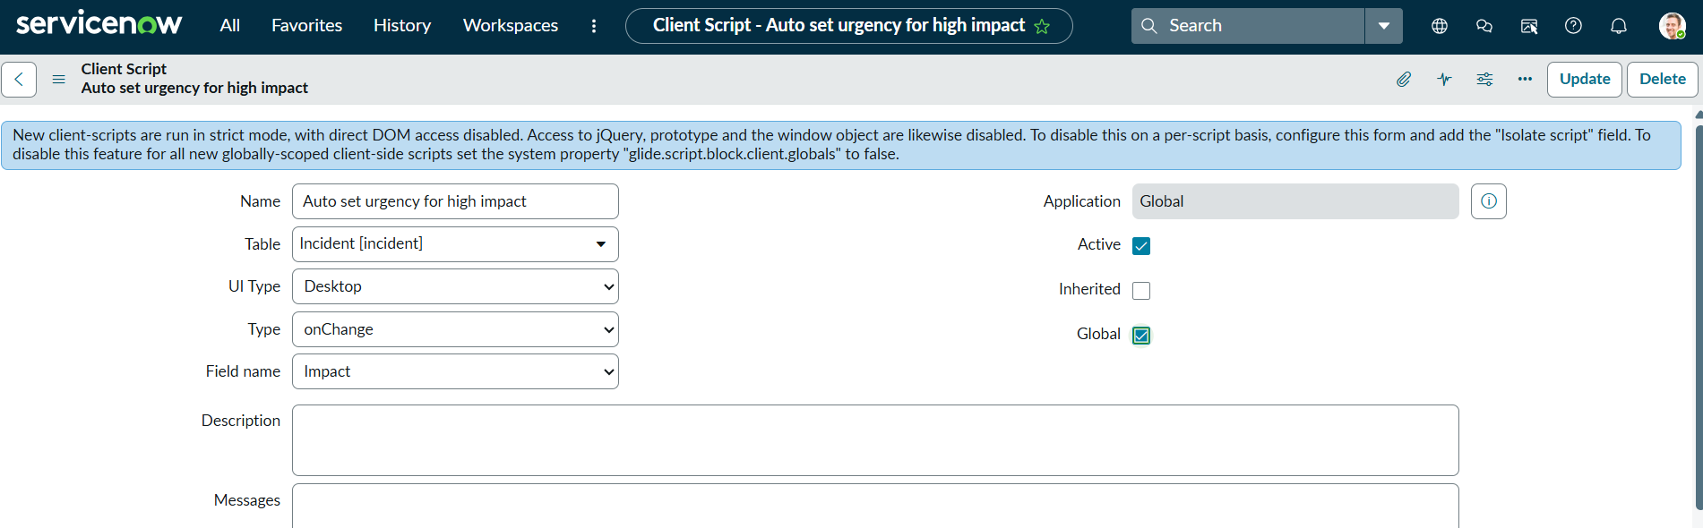  Client Script configuration evidence  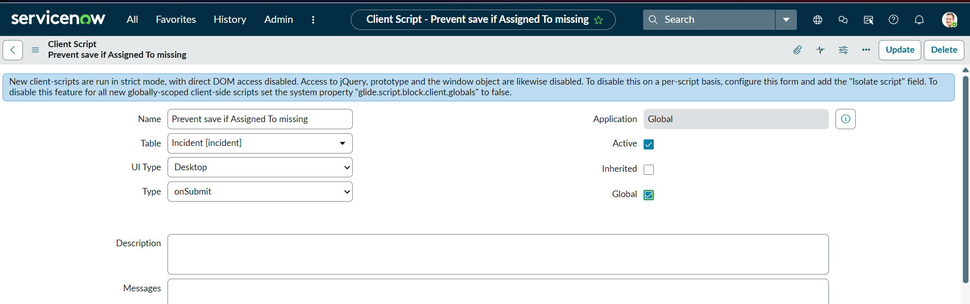  Client Script configuration evidence
3. | Configuration Refinement (if Done) | Configuration includes a Client Script for Incident form behavior and a Client Script for restricting state changes through list editing.  No performance metric or tuning result is applicable to this configuration-only project.  Result: To be verified. | 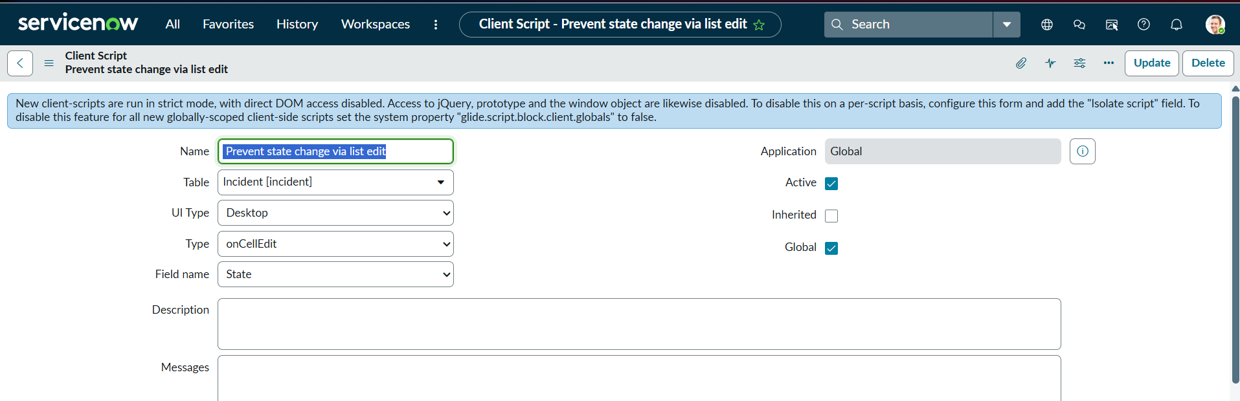  List-edit Client Script configuration evidence

